UCRLsidebarMOD

LLNL-TR-678609

October 28, 2015

S. A. Carroll

M. M. Smith

**Chlorite, Illite, and Biotite Dissolution Kinetics at Variable pH and Temperatures up to 280 °C**

**Chlorite, Illite, and Biotite Dissolution Kinetics at Variable pH and Temperatures up to 280 °C**

**Susan A. Carroll & Megan M. Smith, LLNL**

**Summary**

Sheet silicates and clays are ubiquitous in geothermal environments. Their dissolution is of interest because this process contributes to scaling reactions along fluid pathways and alteration of fracture surfaces, which could affect reservoir permeability. In order to better predict the geochemical impacts on long-term performance of engineered geothermal systems, we have measured chlorite, illite, and biotite dissolution and developed generalized kinetic rate laws that are applicable over an expanded range of solution pH and temperature for each mineral. Here we report updated rate laws for chlorite (Carroll and Smith 2013) and illite (Carroll and Smith, 2014) and for biotite based on data collected FY2015. All rate laws, *R (mol m-2s-1)*, take the following form

(1)



where *SA* is the total mineral surface area (m2), *A*acid, *A*neut, and *A*basic (mol m-2s-1) are the apparent pre-exponential rate factors, and *E*acid, *E*neut, and *E*basic (kJ mol-1) are the activation energies for the acid, neutral and basic mechanisms that account for temperature dependence, and *n* and *m* account for the rate dependence on H+(aq) and OH-(aq), respectively. The form of this equation, which includes a reaction affinity term to slow reaction as equilibrium is approached, can be incorporated into most existing reactive transport codes for use in prediction of rock-water interactions in natural and engineered geothermal systems.

Combination of new data collected at elevated temperature as well as all available published chlorite, (Mg,Al,Fe)12(Si,Al)8O20(OH)16, dissolution datasets results in a kinetic rate equation that is valid over temperatures of 25-275 °C and 3 ≤ pH ≤ 10:

$\begin{aligned}R_{chl}=SA∙\left(\left[4∙{10}^{-5}∙e^{{-30}/{\text{R}\text{∙}\text{T}}}∙a_{H^{+}}^{0.65}\right]+\left[5∙{10}^{-11}∙e^{{-12}/{\text{R}\text{∙}\text{T}}}\right]+\left[2∙{10}^{-9}∙e^{{-15}/{\text{R}\text{∙}\text{T}}}∙a_{{OH}^{-}}^{0.43}\right]\right)\end{aligned}∙\left(1-e^{{∆G_{r}}/{\text{RT}}}\right)$ (2)

Combination of new data collected at elevated temperature as well as all available published illite, K1.8(Al,Fe,Mg)4(Si,Al)8O20(OH)4, dissolution datasets results in a kinetic rate equation that is valid over temperatures of 5-280 °C and 2.6 ≤ pH ≤ 9.7:

 (3)

New data collected at elevated temperature for biotite, K2(Mg,Fe,Al)6(Si,Al)8O20(OH)4, results in a kinetic rate equation that is valid over temperatures of 100-280 °C and 3 ≤ pH ≤ 7.5:

(4)



The chlorite, illite, and biotite rate equations help fill the kinetic data gap for fracture-filling minerals and can be used to assess the impact of geochemical reactions on the sustainability of shear zones for proposed engineered geothermal energy systems (EGS). Reactivity of illite is much greater than biotite and chlorite, with as much as 75% of the initial illite mass dissolving over a 3-4 day experiment. The extent of illite dissolution generally increased with increasing temperature and decreasing pH. Net dissolution of chlorite and biotite was minor over the same time period, although the solution chemistry data suggests that aluminum hydroxides formed at acid pH with increasing temperature.

**1.0 Introduction**

Development of engineered geothermal energy systems (EGS) through the reactivation of fractures in deep hot rocks requires sustained permeability for about 30 years. Chemical reactions pose an important but poorly understood threat to EGS long-term success, because critical kinetic data necessary to fully assess the risk are lacking for most fracture-filling minerals at EGS target temperatures. The poor understanding of the impact of rock-water interactions on fracture permeability is illustrated by variable results from experimental laboratory studies on fractured rock cores. Some data suggest that chemical reactions can significantly reduce fracture permeability even at temperatures much lower than EGS target zones (200 to 400°C) (Polak et al, 2003; Carlson et al, 2005; Viani et al, 2005; Yasuhara et al, 2006, 2011; Yasuhara and Elsworth, 2008), while others in chemically perturbed environments (e.g., undersaturated or CO2-rich) show an increase in fracture permeability (Polak et al., 2004; Smith et al., 2013a). It is important to correctly assess the role of chemistry on EGS permeability, because reductions in fracture permeability will negatively affect heat transfer, possibly rendering the EGS system uneconomic. In principle the role of geochemistry could be assessed through modeling. Unfortunately, kinetic data and rate equations are lacking for fracture filling minerals at EGS temperatures (200 to 400°C) and are rare even to 100 °C (Cama et al, 2000; Brandt et al., 2003; Gustaffson & Puidomenech, 2003; Kohler et al., 2003; Carroll and Knauss 2005; Lowson et al., 2005, 2007; Smith et al., 2013b). Use of reaction rates extrapolated from low temperature may overpredict dissolution by up to 10,000 times at typical EGS temperatures, leading to poor estimates of impact of geochemical alteration on EGS permeability (Smith et al., 2013b).

We address this need by measuring dissolution rates and deriving rate equations for fracture minerals identified in shear stimulation zones at EGS demonstration sites. The resulting rate equations can be directly incorporated into larger scale reactive transport simulations to assess the impact of geochemical reactions on shear zone permeability. In order to better predict the geochemical impacts on long-term performance of engineered geothermal systems, we have measured chlorite, illite, and biotite dissolution and developed generalized kinetic rate laws applicable over an expanded range of solution pH and temperature for each mineral. Here we report updated rate laws for chlorite (Carroll and Smith 2013) and illite (Carroll and Smith, 2014) and for biotite based on data collected FY2015.

**2.0 Materials & Methods**

Chlorite (Mg-rich variety, clinochlore, with trace rutile impurities), identical to that used in previous work (Smith et al., 2013b) and purchased from the Source Clays Repository (Flagstaff Hills “CCa-2” chlorite, El Dorado County, California; described by Post and Plummer, 1972), was used in these experiments. Mineral dissolution rates were calculated from dissolved silica concentrations using the stoichiometry determined by Smith et al. (2013b) of (Mg4.29Al1.48Fe0.10)(Al1.22Si2.78)O10(OH)8 by electron microprobe and verified with transmission electron microscopy (TEM). The bulk specimen was crushed to pea-size; a reserved portion was then mechanically milled to the 150-250 μm size fraction used in the experiments. Multi-point N2-BET surface area measurements of the bulk, unreacted micro-mill-ground “CCa-2” chlorite grains provided a value of 4.9 ±0.3 m2 g-1, similar to the estimate of 5.1 ±0.4 m2 g-1 for the hand-crushed “CCa-2” chlorite used in Smith et al. (2013b). Chlorite samples reacted in neutral and basic solution pH experiments displayed post-reaction surface area values that were up to three times lower than initial unreacted values. For the purposes of calculating dissolution rates, we use post-reaction measured surface areas, because these values describe conditions closer in time to the steady-state behavior of silica concentrations used to derive these rates. The low iron content and initial surface area differ from values reported for this mineral by the Clay Minerals Society, but have been independently replicated by another research group (Black and Haese, 2014).

The illite used in this study was purchased from the Clay Minerals Society as Special Clay IMt-1. The material was mechanically crushed and sieved to collect the 150-250 μm size fraction. In keeping with previously published geochemical experimental work on similar layered silicates (e.g., Sass et al., 1987; Kohler et al., 2003), this size fraction was further treated with an acid wash to remove potential carbonate impurities (Zavarin et al., 2012). The mineral separates were then dried and re-sieved, and stored for further characterization analysis and kinetic experimentation. The initial surface area of the unreacted 150 – 250 mm size fraction was 34.2 g m-2 as measured by multi-point N2 BET. The chemical composition, K1.55(Na0.04,Ca0.02)Al2.90(Fe0.70,Mg0.54,Ti0.05)Si6.75Al1.25O20(OH)4, was determined by electron microprobe (EMP) and transmission electron microprobe (TEM) analyses. Illite contained some trace amounts of quartz and K-feldspar as detected in both powder diffraction pattern and in the TEM analysis. Comparison of XRD patterns for dry and ethylene glycolated samples show that the sample is predominately illite with no indication of expandable smectite clays.

A Mg-rich biotite variety (phlogopite) was procured from Dr. Young-Shin Jun (Washington University, St. Louis, USA) and micro-milled to obtain the 150-250 μm size fraction used in dissolution experiments. Electron microprobe analysis determined the composition of this mineral as K1.89(Na0.10)(Mg5.31Fe0.33Al0.30)4(Si5.71Al2.22)O20(OH)4,, and showed little to no impurities. XRD and TEM analysis confirmed the biotite/phlogopite crystal structure as well as the characteristic 10-Å basal spacing. No post-reaction TEM analysis has yet been conducted.

All experiments were performed in a background matrix of reagent-grade 0.05m NaCl and distilled deionized water initially purged with N2 gas to remove atmospheric oxygen. Reagent-grade hydrochloric acid (HCl) and sodium hydroxide (NaOH) were commonly used to adjust the pH of individual solutions to desired levels. Total chloride levels in the experimental solutions were maintained at a constant value of 0.05m, but sodium levels varied up to 0.075m as a result of pH adjustment by sodium hydroxide. Approximately 1g of unreacted mineral was used for each single temperature/pH flow-through experiments, with larger masses (~1.5g) used for stacked illite experiments. Stacked experiments refer to those experiments in which illite dissolution rates were measured at variable temperature (constant pH) using the same solid.

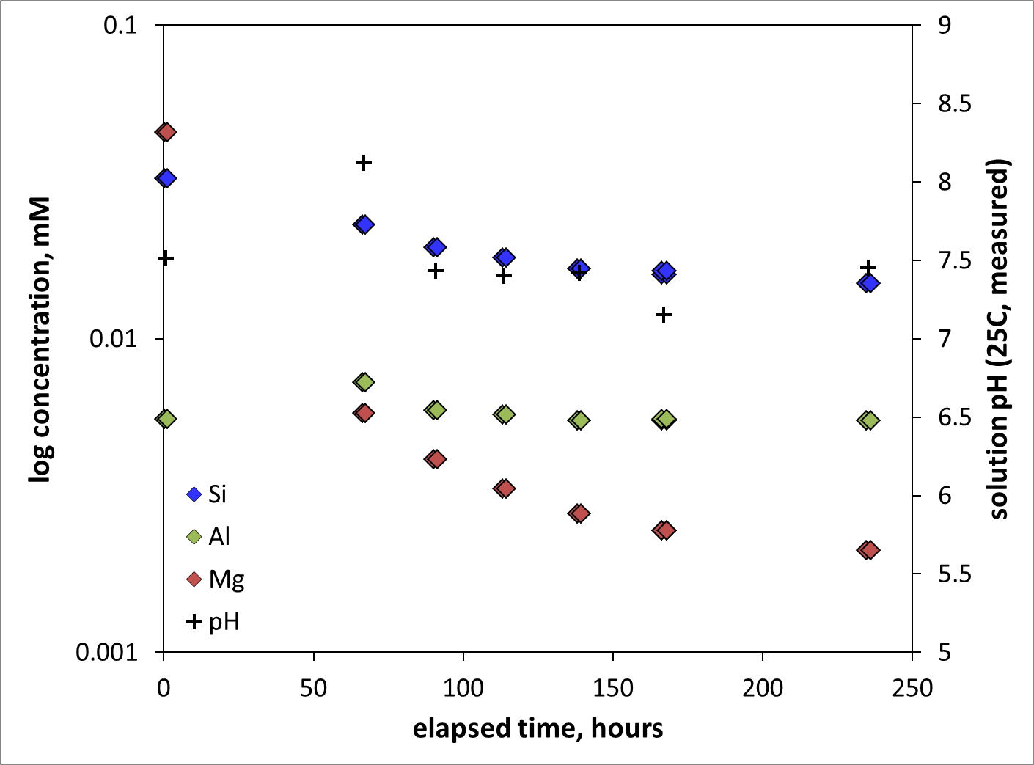

**Figure 1:** Typical experimental solution chemistry as a function of time for illite dissolution experiments conducted with neutral and basic pH solutions. Example is from experiment ILS-3 conducted at 100 °C with influent pH 7.4.

Titanium single-pass mixed-flow reactors (e.g., Dove and Crerar, 1990) were used to conduct chlorite dissolution experiments over a temperature range of 100-280 °C and a pH range of 3-10 at far-from-equilibrium conditions. A schematic of the experimental set-up is shown in Smith et al. (2013b). Room temperature NaCl solutions were pumped into the experimental reactors to pressurize the system, and then the reactor was brought to temperature over a period of several hours while influent solution continued to flow at a constant flowrate of 0.5 mL min-1. We refer to time *t* = 0 in the discussion and figures below as the time when the reactor system achieved its target temperature. Influent

solution flowed up over the illite grains held between fine titanium meshes in an isolated sample holder within the experimental reactor, ensuring continuously mixed conditions. Reactor system pressures were maintained well above boiling point pressures by the use of a dome-loaded back-pressure regulator and nitrogen gas at the reactor outlet. All wetted reactor surfaces (including the pump and back-pressure regulator) were made of C-276 alloy, passivated grade-4 titanium, or PEEK. To conclude each experiment, the reactor heaters were turned off and the sample holder was removed from each reactor as soon as liquid temperatures decreased below 100 °C. Sample holders were dried overnight at 60 °C and illite solids were then removed and preserved for post reaction characterization. Each reactor and pump was cycled with a mildly acidic (pH 4) HCl solution and then at least 24 hours of distilled water rinsing between experiments, and reactor parts were periodically boiled in 8N nitric acid and re-passivated.

Samples were collected directly downstream of the back-pressure regulator through a luer-lock port using 60-mL disposable syringes. Effluent samples were split into three aliquots for analysis: 15 mLs were filtered (0.2 um) and acidified for major and trace element analysis (silicon, magnesium, aluminum, potassium, iron, and/or calcium) by inductively-coupled plasma optical emission spectrometry (ICP-OES); 1 mL was filtered and diluted by 10x distilled water for ion chromatography (IC) to confirm consistent background sodium and chloride matrix concentrations and to confirm potassium levels; 3-5 mLs were reserved, unfiltered, for 20 °C pH measurement. The geochemical code EQ3/6 (Wolery, 1992) and the updated *data.ymp* database were used to calculate solution pH at experimental temperatures as well as mineral-specific fluid saturation indices. To avoid propagating large errors from IC measurements into the calculation of solution pH, each solution chemistry dataset was first charge-balanced (on chloride, Cl-) at 25 °C using measured solution pH values, and then modeled at the experimental temperature for determination of *in situ* solution pH.

**3.0 Results & Discussion**

In this section we discuss the chlorite, illite, and biotite dissolution rate data and the resulting rate laws. All rate laws, *R (mol m-2s-1)*, take the following form

(1)



where *SA* is the total mineral surface area (m2), *A*acid, *A*neut, and *A*basic (mol m-2s-1) are the apparent pre-exponential rate factors, and *E*acid, *E*neut, and *E*basic (kJ mol-1) are the activation energies for the acid, neutral and basic mechanisms that account for temperature dependence, and *n* and *m* account for the rate dependence on H+(aq) and OH-(aq), respectively. The final term represents some functional dependence of the overall rate on the Gibbs free energy of reaction, Δ*G*r, to slow the reaction rate as equilibrium is approached. Specific rate parameters values are included in the mineral-specific rate equations (2-4). Final equations were derived by means of graphical fitting to extract activation energies, literature to constrain dependence on solution pH, and PEST (parameter optimization code, Doherty et al., 2005). It is important to note that the generalized kinetic rate equaitons yielded highly correlated mechanism-specific parameter values (e.g., *A*A, *E*A, *n* and *m* all strongly correlated) when fit to the data. Given this non-uniqueness (also noted by Cama et al., 2000) graphical methods or literature values of independently estimating *E*i, *n*, and *m* were utilized to reduce the number of unknown model parameters. The resulting rate equations can be incorporated into most existing reactive transport codes for use in prediction of rock-water interactions in engineered geothermal systems.

**3.1 Chlorite**

We limit our discussion of chlorite dissolution rates to the derivation of the rate law and key findings. Additional details can be found in Smith and Carroll (2015) which as been accepted for publication. The recommended rate equation for chlorite, (Mg,Al,Fe)12(Si,Al)8O20(OH)16, is dependent on both pH and temperature and utilizes three different dissolution mechanisms (acid, neutral, and basic), and was derived from 100-275 °C rate data collected in this study and the companion work (Smith et al., 2013b) as well as available published data from other sources from 25-120 °C (Brandt et al., 2003; Lowson et al., 2005, 2007; Black and Haese, 2014; Zhang et al., 2015). The data and fit to rate equation is shown in Figure 2. Combination of new data collected at elevated temperature as well as all available published chlorite dissolution datasets results in a kinetic rate equation that is valid over temperatures of 25-275 °C and 3 ≤ pH ≤ 10:

$\begin{aligned}R_{chl}=SA∙\left(\left[4∙{10}^{-5}∙e^{{-30}/{\text{R}\text{∙}\text{T}}}∙a_{H^{+}}^{0.65}\right]+\left[5∙{10}^{-11}∙e^{{-12}/{\text{R}\text{∙}\text{T}}}\right]+\left[2∙{10}^{-9}∙e^{{-15}/{\text{R}\text{∙}\text{T}}}∙a_{{OH}^{-}}^{0.43}\right]\right)\end{aligned}∙\left(1-e^{{∆G_{r}}/{\text{RT}}}\right)$ (2)

These estimated energies are relatively low compared to the reported range for layered silicate minerals (~20-90 kJ mol-1) and are 3-4 times lower than previously estimated values for chlorite dissolution (Nagy, 1995; Palandri and Kharaka, 2004), but are consistent with values previously reported by Smith et al. (2013b) and Black and Haese (2014).

Those rates with Δ*G*r ≥ -65 kJ mole-1 (rates *closer* to equilibrium, n = 58) were used to assess the appropriateness of various reaction affinity terms *f*(Δ*G*r). We find that chlorite dissolution is best described by a reaction affinity term based on transition-state theory as defined in equation (1), suggesting that the approach to equilibrium should lower the rate only when solutions are very close to equilibrium, i.e., rates with Δ*G*r ≥ -2 kJ mol-1 (*SI* > -0.5).

We find that the dissolution of chlorite, a sheet-silicate, is relatively slow at elevated temperatures (100-275 °C), compared to other framework silicate minerals for which higher-temperature kinetic data are available (e.g., quartz and feldspars; see Palandri and Kharaka, 2004). This finding and the overall variation of only ~2 orders of magnitude difference in rate values measured over 25 to 275 °C, provides the basis for relatively lower activation energies for the specific rate mechanisms, in conflict with previously reported high activation energies for chlorite based on extrapolation of low-temperature experimental data to higher temperatures. Additionally, we note that the dissolution rate of chlorite does not increase in alkaline pH conditions, as has been noted for other minerals, but rather remains at the same level as that noted for neutral conditions, with only a weak dependence on temperature. The available rate data at high pH cannot differentiate whether this lack of rate dependence at alkaline pH is due to decreased effects of hydroxide-catalyzed reaction or increased effects of fluid saturation under these conditions.

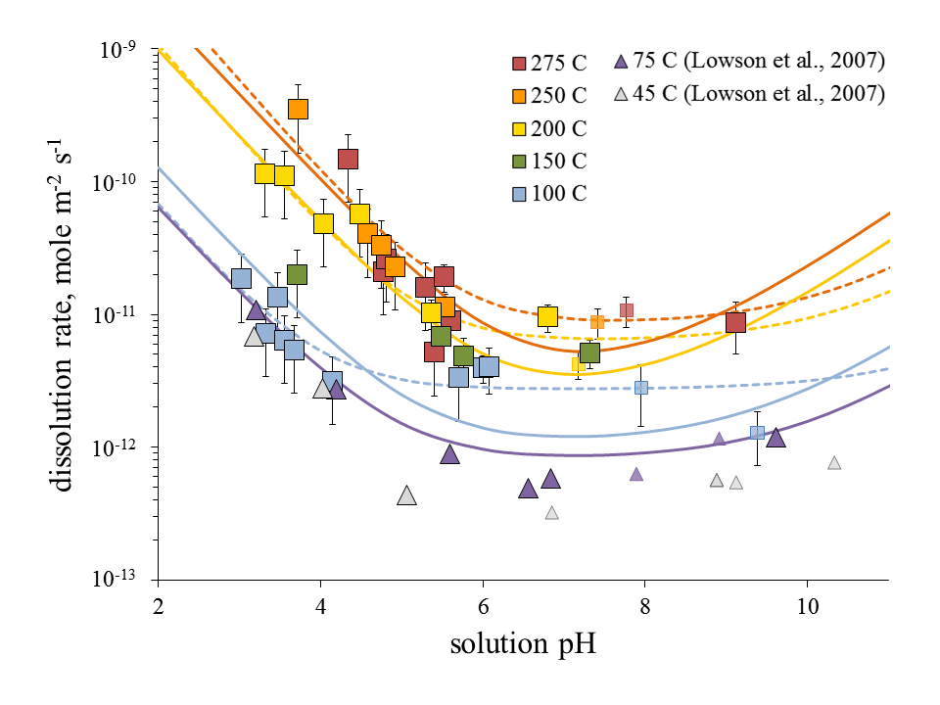

**Figure 2:** Chlorite dissolution rates versus solution pH, from this work and Smith et al., 2013, (□); and Lowson et al., 2007 (∆). Solid lines represent fitted rates at corresponding temperatures calculated from 25-275 °C equation (2); dashed lines represent fitted rates calculated from 100-275 °C (see Smith and Carroll, 2015). Smaller symbols represent rates measured under Δ*G*r ≥ -65 kJ mol-1 conditions.

**3.2 Illite**

Illite, K1.8(Al,Fe,Mg)4(Si,Al)8O20(OH)4, is highly reactive at geothermal temperatures, resulting in the precipitation of α/ϒ-AlOOH phases at pH < 4 and 150 to 280°C. The secondary phase sandwiched between illite layers near the grain surface was identified as diaspore (α -AlOOH) with high resolution TEM analysis, whereas the precipitate that formed from solution was identified as boehmite (γ-AlOOH) by XRD. No aluminosilicate phases (such as talc or kaolinite) were detected from XRD or TEM analysis. No secondary phases were detected when illite was reacted at neutral or basic pH.

The non-stoichiometric concentrations of K, Al, and Si in the aqueous samples used to measure the dissolution rate are consistent with the detection of AlOOH phases found in the reacted illite. Figure 3 shows the ratio of steady-state dissolved aluminum and silica concentrations from all experiments. Aluminum is highly depleted relative to silica for experiments conducted at pH < 6, as a result of retrograde aluminum solubility at elevated temperature (Bourcier et al., 1990). Similar observations have been made for feldspar dissolution (Carroll and Knauss, 2005). Over the range of pH 6-8, aluminum to silica ratios approach the value measured in the unreacted illite, and for pH > 8, dissolution appears to proceed roughly stoichiometrically with respect to these two elements. In contrast, ratios of potassium to silica release are largely stoichiometric across the range of pH 3-10 for all temperatures greater than 100 °C. The 100 °C data display increasingly non-stoichiometric K:Si behavior at neutral pH, with values decreasing to that found in the original illite material at 3 > pH > 8. This non-stoichiometric K:Si release at 100 °C is not fully understood, as thermodynamic modeling shows that fluids are undersaturated with respect to illite at this temperature for all pH conditions.

Silica concentrations were used to derive the rates shown in Figure 4 because this element best reflects wholesale dissolution of illite, and should not be affected by the precipitation of the aluminum oxyhydroxide. Arrhenius plots (natural log of measured rates versus inverse temperature) were used to estimate apparent activation energies over discrete pH intervals to account for the temperature dependence of illite dissolution (Figure 4). A single activation energy equal to 58 KJ/mol can be used to describe the temperature dependence of the acid, neutral, and basic mechanisms. Dissolved silica rates were corrected to the final amount of illite in the sample, calculated from integration of the each experiment’s silica concentration data with time and constant flowrate. Activation energies were estimated from the best-fit slopes from 5 - 275 °C. Lower temperature data was from Köhler et al., (2003) and Bibi et al (2011). Rates estimated from the dissolved aluminum are lower than those based on dissolved silica, consistent with precipitation of a secondary aluminum-bearing phase with increasing temperature and decreasing pH (data not shown). Rates based on dissolved silica concentrations at 250 and 280 °C also fall off the trend established by silica concentrations below 150 °C at pH <3.5. We attribute these lower values to the extensive dissolution of illite and uncertainty in estimating the final amount of illite and its reactive surface area.

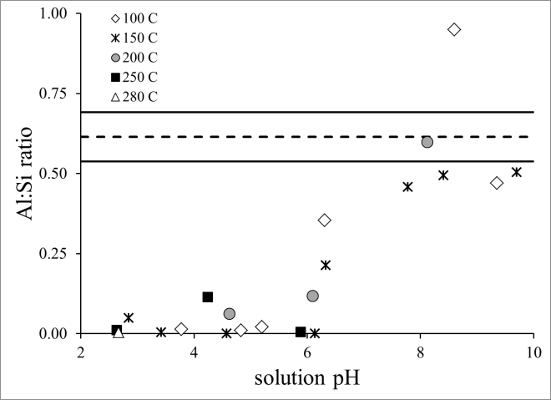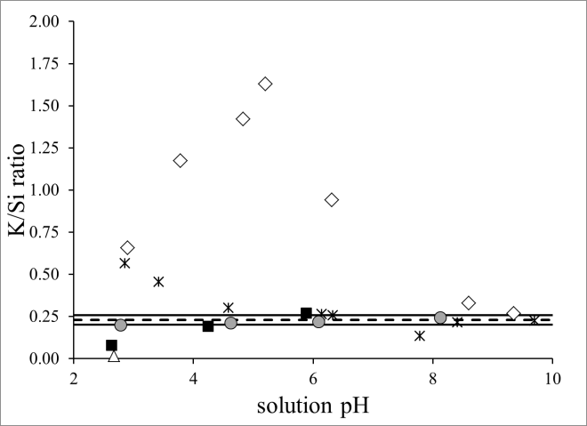

**Figure 3**: Illite dissolution ploted as a) dissolved Al:Si, and b) K:Si as a function of pH. The Al:Si and K:Si in the unreacted illite is represented by the dashed horizontal lines. The solid lines bounding each dashed line represent uncertainty in the original illite ratios as determined by 20+ electron microprobe spot analyses.

Combination of new data collected at elevated temperature in this study as well as all available published illite dissolution datasets (Bibi et al., 2011; Köhler et al., 2003) results in a kinetic rate equation that is valid over temperatures of 25-280 °C and 3 ≤ pH ≤ 10:

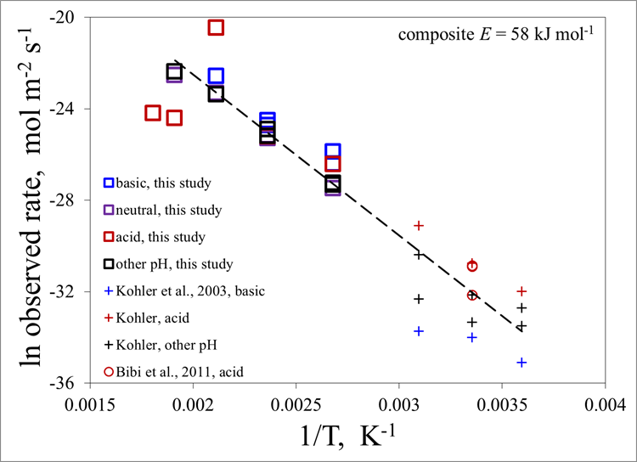Figure 4. Natural log observed illite dissolution rates versus inverse temperature (K-1). All rates shown are derived from aqueous silica concentrations. The apparent activation energy derived from all available Si-derived rates is 58 kJ mol-1 represented by the slope of the dashed black line.

 (3)

The fit of this rate equation to the rate data obtained in this study is shown in Figure 5. We are in the process of deriving boehmite precipitation rates from the high temperature data.

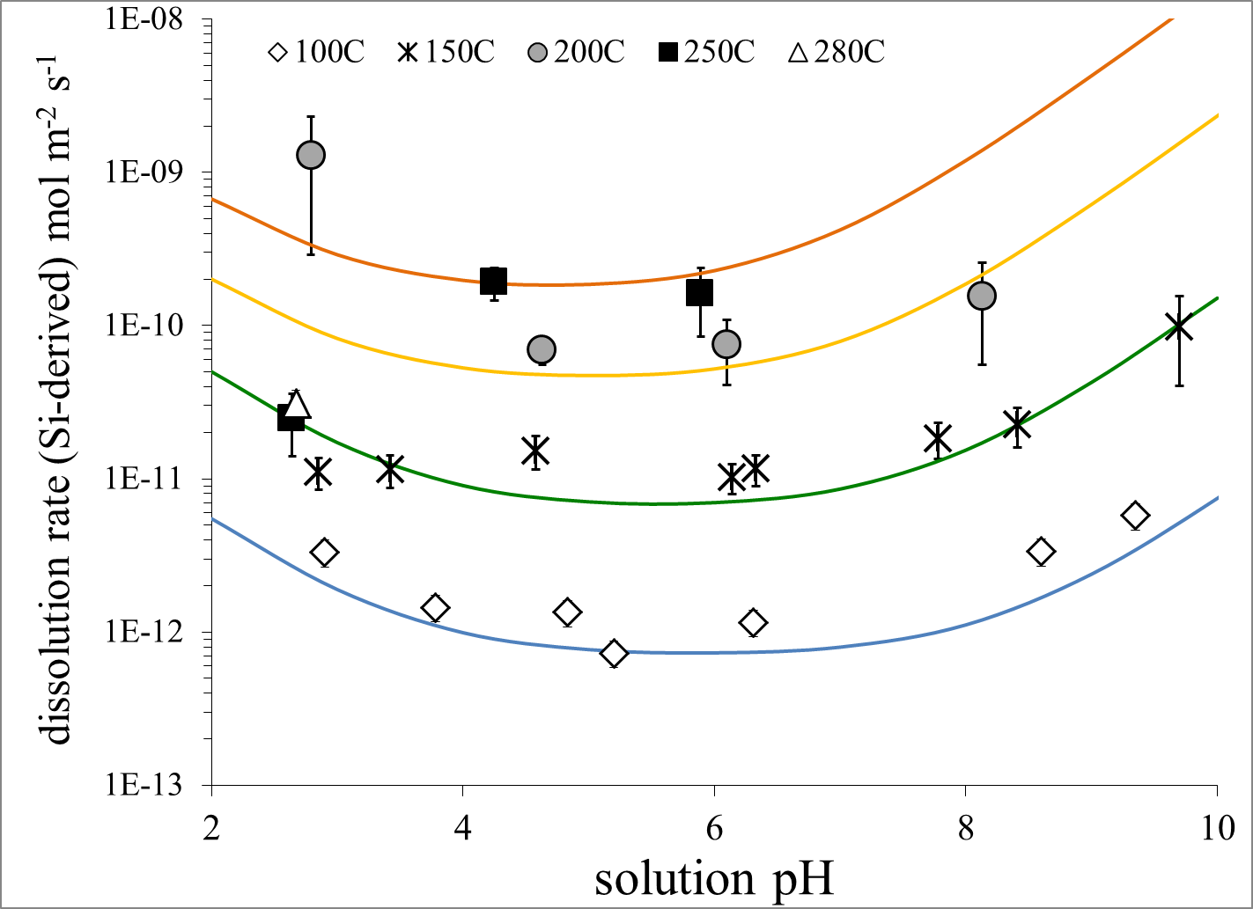**Figure 5**: Illite dissolution rates versus solution pH for experiments at temperatures 100-280 C (this work). Curves indicate rates predicted by equation (3).

**3.3 Biotite**

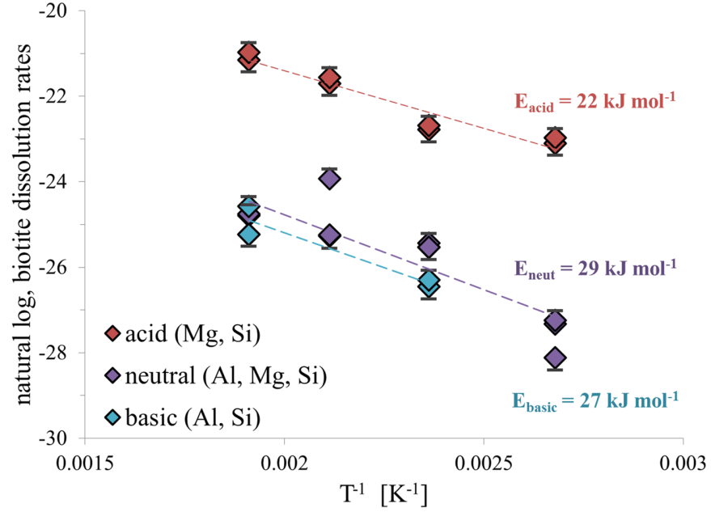**Figure 6**: Biotite dissolution rates versus inverse temperature, for three pH regimes (acid, neutral, and basic) with corresponding apparent activation energies (*E*i).

Like chlorite and illite, the stoichiometry of biotite, K2(Mg,Fe,Al)6(Si,Al)8O20(OH)4, dissolution depended on solution pH. At acid conditions, silica, magnesium, and potassium are released congruently, but aluminum was not and appears to be affected by the precipitation of a secondary phase. As pH increases through neutral and slightly alkaline values, aluminum and silica release was stoichiometric, but magnesium release rates were slowed relative to silica and potassium release rates are consistently faster (three orders of magnitude) than silica rates. The much higher potassium release rates could suggest secondary mineral precipitation or preferential release of potassium from the interlayer sites. Future high resolution TEM analysis will inform the mechanism. At the time of writing this report we evaluate biotite dissolution using rates calculated with dissolved silica over the pH range.

Arrhenius plots were used to estimate apparent activation energies over discrete pH intervals to account for the temperature dependence of biotite dissolution (Figure 6). Apparent activation energy values *E*acid = 22, *E*neut = 29, and *E*basic = 27 (kJ mol-1). Parameters *n* and *m* were fitted graphically, although it should be noted that few data points are available to truly constrain the alkaline parameter *m*. Graphical and visual fitting resulted in a kinetic rate equation for biotite dissolution as:

(4)



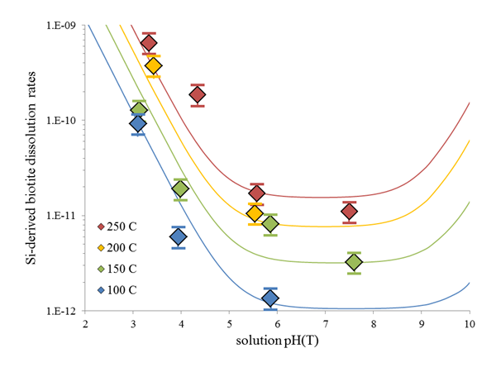**Figure 7**: Biotite dissolution rates versus pH. Rate predictions are shown as lines of corresponding color.

The fit of the rate equation (4) to the biotite data is shown in Figure 7. The data set nicely captures the pH dependence from pH 3 to 8 and 100 to 280 °C, but more data are needed to constrain the alkaline pH trends at all temperatures. The biotite rate equation will be updated upon analysis of the solution chemistry from six additional experiments (100°C and pH 7.5; 200°C and pH 4 & 7.5; and 280°C and pH 3, 5.5, and 7.5) and inclusion of data from lower temperature studies (e.g., Lin and Clemency, 1981; Kalinowski and Schweda, 1996; Malmström and Banwart, 1997; Taylor et al., 2000; Shao et al., 2010). In equation 4 we adopt the same reaction affinity form as for chlorite and illite.

**4.0 Conclusions and Implication for EGS**

The rate equations summarized in this report should be of use to those who wish to better assess the impacts of geochemical alteration on long-term fracture permeability for EGS systems supported by industry and the Geothermal Program. This is important because geochemical alteration, changing stress fields, mass transport and heat transfer incorporated into computational models are needed to optimize geothermal energy production for EGS systems.

We have measured chlorite, illite, and biotite dissolution rates from 100 to 280 °C and pH 3 to 10 to develop comprehensive rate equations that can be used to assess the impact of geochemical reaction on the sustainability of shear zone in natural and/or engineering geothermal reservoirs. The resulting rate equations are dependent on pH, temperature, and reaction affinity and utilize specific dissolution mechanisms (acid, neutral, and basic mechanisms). Rate parameters were derived from data collected at LLNL, and supplemented wherever possible by published rates collected at lower temperatures. The resulting rate equations should be easy to incorporate into most existing reactive transport codes for use in prediction of rock-water interactions in geothermal systems. Data are still lacking for other fracture-filling minerals (epidote, muscovite, K-feldspar) and for silicate minerals in general at near-equilibrium conditions. The new rate equations are an improvement on extrapolating rates from equations based on low-temperature experiments.

Key findings from the study include

* The rate equations more accurately capture geochemical rates at geothermal conditions than extrapolating available low-temperature equations to higher temperatures. Chlorite rates are up to 10,000 times lower, and illite and biotite rates are 10 to 100 times higher than estimated by extrapolation of low-temperature equations to geothermal temperatures.
* Illite is significantly more reactive than chlorite and biotite. Illite dissolution increases by 1000 times from 100 to 280 °C, whereas chlorite and biotite increase by only 10 times over the same temperature range.
* The high reactivity of illite is likely to drive chemical alteration in shear zones. Assuming similar abundances and surface areas, reactivity of illite is much greater than biotite and chlorite, with as much as 75% of the initial illite mass dissolving over a 3-4 day experiment.

All rate equations and data have been submitted to the Geothermal Data Repository, and biotite rates will be updated as more data becomes available. LLNL will develop rate equations for muscovite and K-feldspar in FY16, because these common fracture-filling minerals have no data above 70 °C (muscovite) and 150 °C (K-feldspar).

**Acknowledgements**

We acknowledge support of this research through the U.S. Department of Energy, Geothermal Technologies Program. We also wish to thank LLNL personnel Cora Madden, Rachel Lindvall, and Victoria Genetti for solution analysis. This work was performed under the auspices of the U.S. Department of Energy by Lawrence Livermore National Laboratory under contract DE-AC52-07NA27344. LLNL-TR-663071

**References**

Bibi I., Singh B., and Silvester E. 2011. Dissolution of illite in saline-acidic solutions at 25 °C. *Geochimica et Cosmochimica Acta* **75**, 3237-3249.

Black J, RR Haese. 2014. Chlorite dissolution experiments under CO2 saturated conditions from 50 to 120

°C and 120 to 200 bar CO2. *Geochimica et Cosmochimica Acta*, 125:225-240.

Bourcier, W.L., Knauss, K.G., Jackson, K.J., 1993. Aluminum hydrolysis constants to 2508C from boehmite solubility measurements. *Geochim. Cosmochim. Acta* 57, 747–762.

Brandt F, D Bosbach, R Krawczyk-Bärsch, T Arnold, G Bernhard. 2003. Chlorite dissolution in the

acid pH range: A combined microscopic and macroscopic approach. *Geochim et Cosmochim Acta*, 67: 1451-1461. 10.1016/S0016-7037(02)01293-O.

Cama J., Ganor J., Ayora C., Lasaga C.A. 2000. Smectite dissolution kinetics at 80°C and pH 8.8. *Geochimica et Cosmochimica Acta*, 64, 2701-2717.

Carlson S.R., Roberts J.J., Detwiler R.L., Viani B.E., Roberts S.K. (2005) Fracture permeability evolution in Desert Peak Quartz Monzonite. *GRC Transactions*, 29, 337-342.

Carroll, S. A. and Smith M. 2013. Chlorite dissolution kinetics at variable pH and temperatures up to 280°C. Lawrence Livermore National Laboratory, LLNL-TR-644422

Carroll, S. A. and Smith M. 2014. Illite dissolution kinetics at variable pH and temperatures up to 280°C. Lawrence Livermore National Laboratory, LLNL-TR-663071

Carroll, S. A. and Knauss, K. G. 2005. Dependence of labradorite dissolution kinetics on CO2(aq), Al(aq), and temperature. *Chemical Geology*, **217**, 213-225

Doherty, J. 2005. PEST: Software for model-independent parameter estimation. Watermark Numerical Computing, Australia. Available from *http://www.sspa.com/pest; http://www.pesthomepage.org*.

Dove PM, DA Crerar. 1990. Kinetics of quartz dissolution in electrolyte solutions using a hydrothermal

mixed flow reactor. *Geochim et Cosmochim Acta*, 54:955-969. 10.1016/0016-7037(90)90431-J.

Gustaffson AB, I Puigdomenech. 2003. The effect of pH on chlorite dissolution rates at 25 °C. *Materials*

*Res Soc Symp Proc*, 757:649-655. 10.1557/PROC-757-II3.16

Kalinowski B.E., Schweda P. 1996. Kinetics of muscovite, phlogopite, and biotite dissolution and

alteration at pH 1-4, room temperature. *Geochimica et Cosmochimica Acta*, 60, 367-385.

Köhler S.J., Dufaud F., Oelkers E.H. 2003. An experimental study of illite dissolution kinetics as a function of pH from 1.4 to 12.4 and temperature from 5 to 50°C. *Geochimica et Cosmochimica Acta*, 67, 3583-3594.

Lin F., Clemency C.V. 1981. Dissolution kinetics of phlogopite. I. Closed system. *Clays and Clay Minerals*, 29, 101-106.

Lowson RT, M-CJ Comarmond, G Rajaratnam, PL Brown. 2005. The kinetics of the dissolution of chlorite

as a function of pH and at 25°C. *Geochim et Cosmochim Acta*, 69:1687-1699. 10.1016/j.gca.2004.09.028.

Lowson RT, PL Brown, M-CJ Comarmond, G Rajaratnam. 2007. The kinetics of chlorite dissolution.

*Geochim et Cosmochim Acta*, 71:1431-1447. 10.1016/j.gca.2006.12.008.

Malmström M., Banwart S. 1997. Biotite dissolution at 25 C: The pH dependence of dissolution rate and

stoichiometry. *Geochimica et Cosmochimica Acta*, 61, 2779-2799.

Nagy K.L. 1995. Dissolution and precipitation kinetics of sheet silicates, chapter 5, in Chemical Weather

Rates of Silicate Minerals, *Reviews in Mineralogy* v31, Eds White A.F., Brantley S.L. Mineralogical Society of America, Washington D.C.

Palandri J, YK Kharaka. 2004. A compilation of rate parameters of water-mineral interaction kinetics for

application to geochemical modeling. U.S. Geological Survey Open File Report 2004-1068 (70pp).

Polak A., Elsworth D., Yasuhara H., Grader A.S., Halleck P.M. 2003. Permeability reduction of a natural reaction under net dissolution by hydrothermal fluids. *Geophysical Research Letters*, 30, 2020, doi:10.1029/2003GL017575.

Polak A., Elsworth D., Liu J., Grader A.S. 2004. Spontaneous switching of permeability changes in a limestone fracture with net dissolution. *Water Resources Research*, 40, W03502, doi:10.1029/2003WR002717.

Sass, B.M., Rosenberg P.E., Kittrick J.A. 1987. The stability of illite/smectite during diagenesis: An

experimental study. *Geochimica et Cosmochimica Acta*, 51, 2103-2115.

Shao H., Ray J.R., Jun Y-S. 2010. Dissolution and precipitation of clay minerals under geologic CO2

sequestration conditions: CO2-brine-phlogopite interactions. *Environmental Science and Technology*, 44, 5999-6005.

Smith MM, SDC Walsh, WW McNab, Carroll SA. 2013a. Experimental investigation of brine-CO2 flow through a natural fracture: Permeability increases with concurrent dissolution/reprecipitation reactions. Proceedings, 38th Workshop on Geothermal Reservoir Engineering, Stanford University, Stanford, CA (February 11-13, 2013).

Smith MM, TJ Wolery, SA Carroll. 2013b. Kinetics of chlorite dissolution at elevated temperatures and CO2 conditions. *Chemical Geology*, 347:1-8. 10.1016/jchemgeo.2013.02.017.

Smith M.M., and Carroll S.A. 2015. Chlorite dissolution kinetics at pH 3-10 and temperatures to 275 °C. *Chemical Geology* (in press).

Taylor A.S., Blum J.D., Lasaga A.C., MacInnis I.N. 2000. Kinetics of dissolution and Sr release during biotite and phlogopite weathering. *Geochimica et Cosmochimica Acta*, 64, 1191-1208.

Viani B.E., Roberts J.J., Detwiler R.L., Roberts S.K., Carlson S.R. 2005. Simulating injectate/rock chemical interaction in fracture Desert Peak Quartz Monzonite. *GRC Transactions*, 29, 425-430.

Yasuhara H., Polak A., Mitani Y., Grader A.S., Halleck P.M., Elsworth D. 2006. Evolution of fracture permeability through fluid-rock reaction under hydrothermal conditions. *Earth and Planetary Science Letters*, 244, 186-2000.

Yasuhara H., Kinoshita N, Ohfuji H., Lee D S, Nakashima S, Kishida K 2011. Temporal alteration of fracture permeability in granite under hydrothermal conditions and its interpretation by coupled chemo-mechanical model. *Applied Geochemistry*, 26, 2074-2088.

Wolery TJ. 1992. EQ3/6, a software package for geochemical modeling of aqueous systems. Lawrence Livermore National Laboratory Report UCRL MA-110662-PT-1.

Yasuhara H., Elsworth D. 2008. Compaction of a rock fracture moderated by competing roles of stress corrosion and pressure solution. *Pure and Applied Geophysics*, 165, 1289-1306

Zavarin M., Powell B.A., Bourbin M., Zhao P., Kersting A.B. 2012. Np(V) and Pu(V) ion exchange and surface-mediated reduction mechanisms on montmorillonite. *Environmental Science and Technology*, 46, 2692-2698.

Zhang S., Yang L., DePaolo D.J., Steefel C.I. 2015. Chemical affinity and pH effects on chlorite dissolution kinetics under geological CO2 sequestration related conditions. *Chemical Geology*, 396, 208-217.